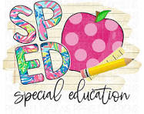

**Villa SPED Activities for Book List**

* Title: Wutaryoo
* All about me
* Animals
* SPED
* [All About me Worksheet](https://www.printablee.com/post_printable-worksheets-about-me_227662/)
* 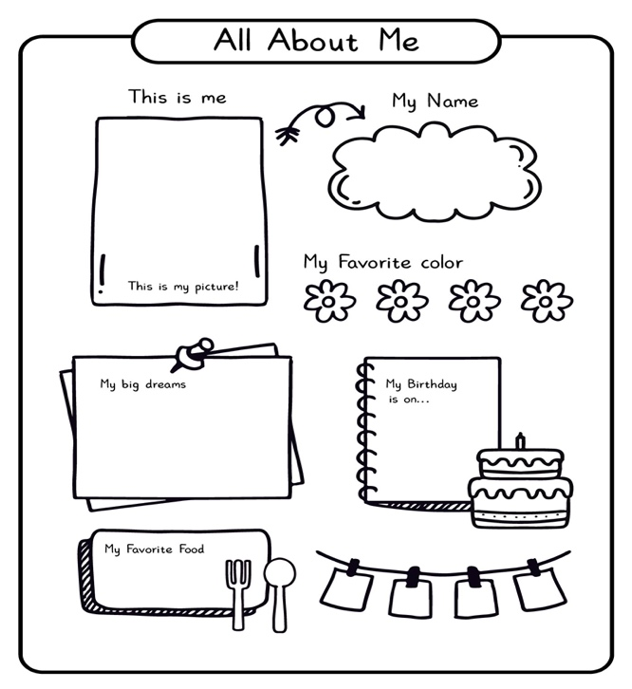
* Title: A Spoon full of Frogs
* Easy Origami
* Animals
* SPED
* [Youtube](https://www.printablee.com/post_printable-worksheets-about-me_227662/)

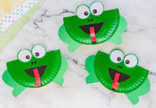

* Title: Song of Frutas
* Read Aloud
* Langues/Culture/food
* SPED
* [Youtube](https://www.youtube.com/watch?v=A09d38jC0PQ)

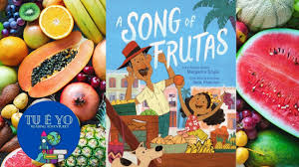

* Title: The Cool Bean
* Magic
* Dancing Beans
* Dance
* SPED
* [Youtube](https://youtu.be/uPOiuy5nX-U?si=cpYKckOmk0Eag5mC)

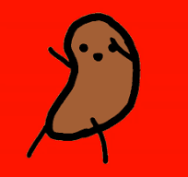

* Title: Gibberish
* Language
* Finger puppets
* SPED

